CloudWatch EC2 Metrics Dashboard
Topic: Open CloudWatch Classic Metrics and locate EC2 monitoring metrics.
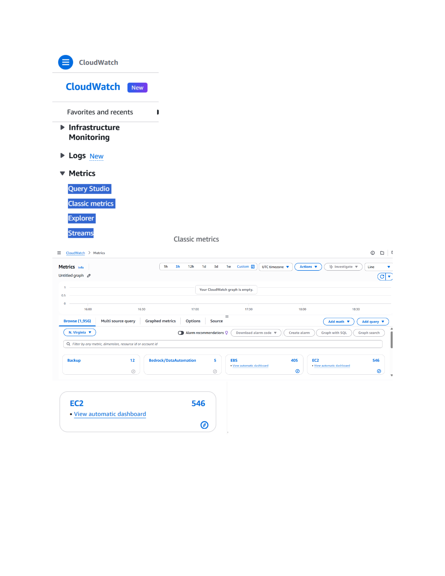
Action: CloudWatch Classic metrics is opened in the N. Virginia region. The EC2 metric category is visible with 546 available metrics, ready for selecting per-instance monitoring data.

Select EC2 CPU Utilization Metric
Topic: Choose an EC2 instance and its CPUUtilization metric.
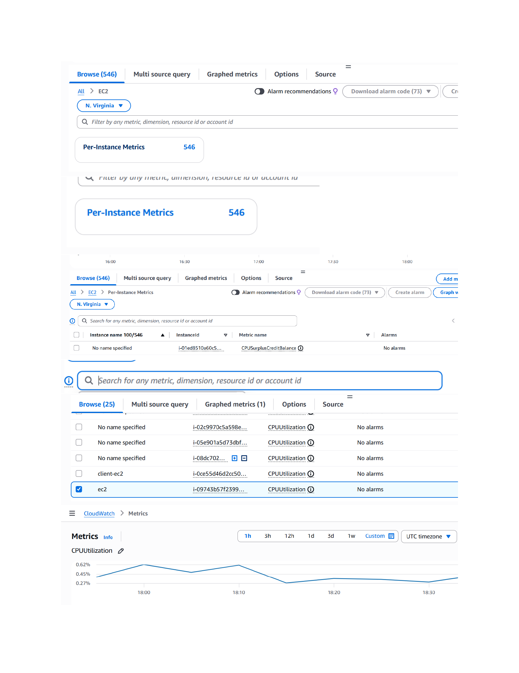
Action: The EC2 metric list is filtered to per-instance metrics. The instance named “ec2” is selected, CPUUtilization is chosen, and the CPU utilization graph is displayed for monitoring.

Create CloudWatch Alarm from CPUUtilization
Topic: Review the CPUUtilization graph and start alarm creation.
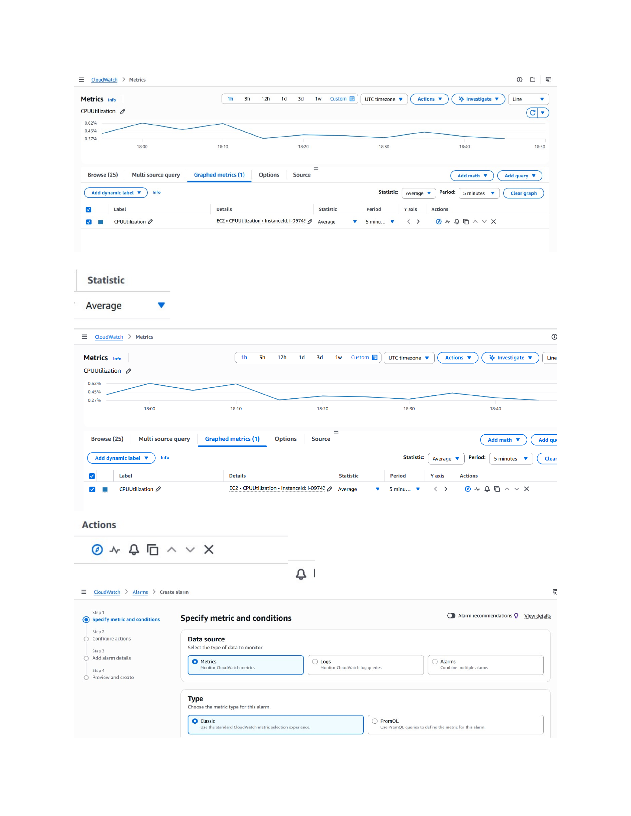
Action: CPUUtilization is shown as a graphed metric with Average statistic and a 5-minute period. The alarm creation workflow is opened and the first step, “Specify metric and conditions,” is selected.

Configure CPU Utilization Alarm Threshold
Topic: Define the alarm condition and notification action.
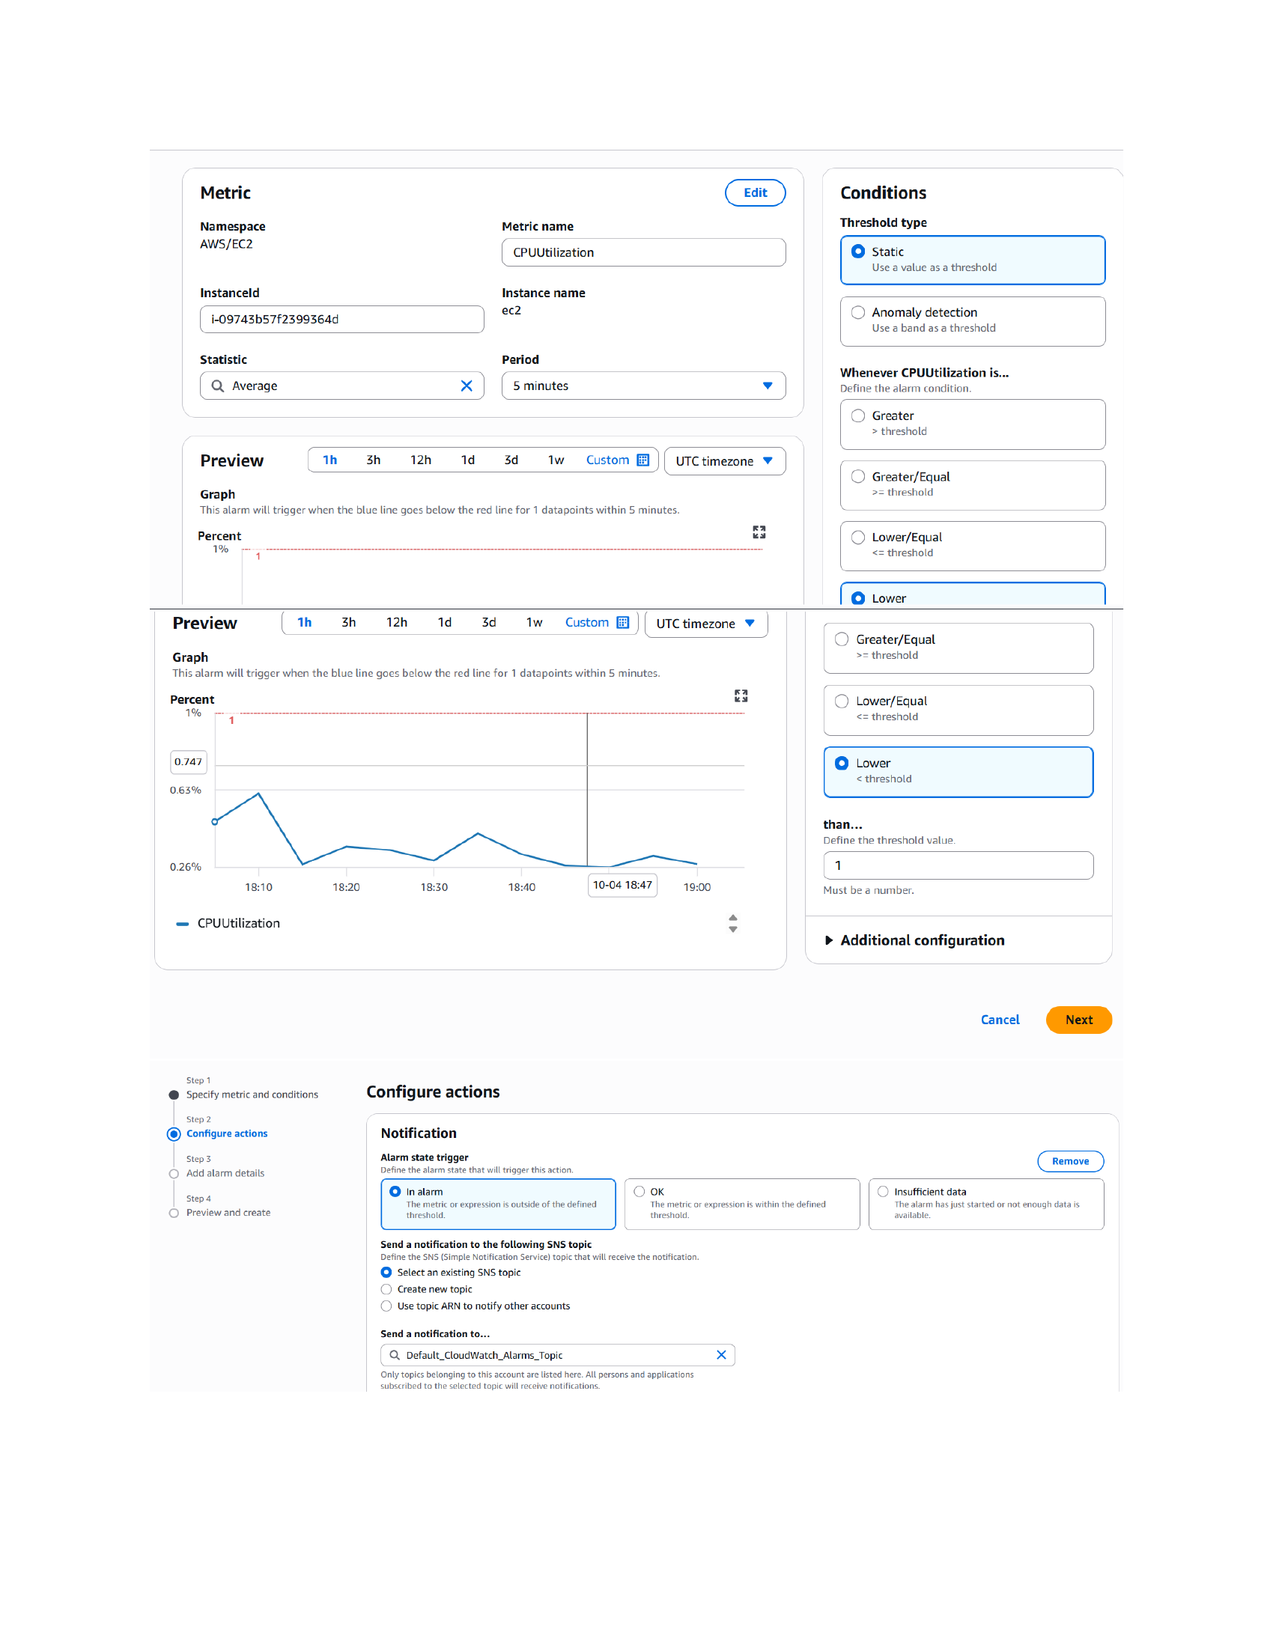
Action: The alarm uses AWS/EC2 CPUUtilization for instance “ec2”, Average statistic and a 5-minute period. A static Lower-than threshold is configured with value 1, then the workflow moves to Configure actions and selects the SNS notification topic.

Create and Verify EC2 High-Low Alarm
Topic: Add alarm details and verify the resulting alarm state.
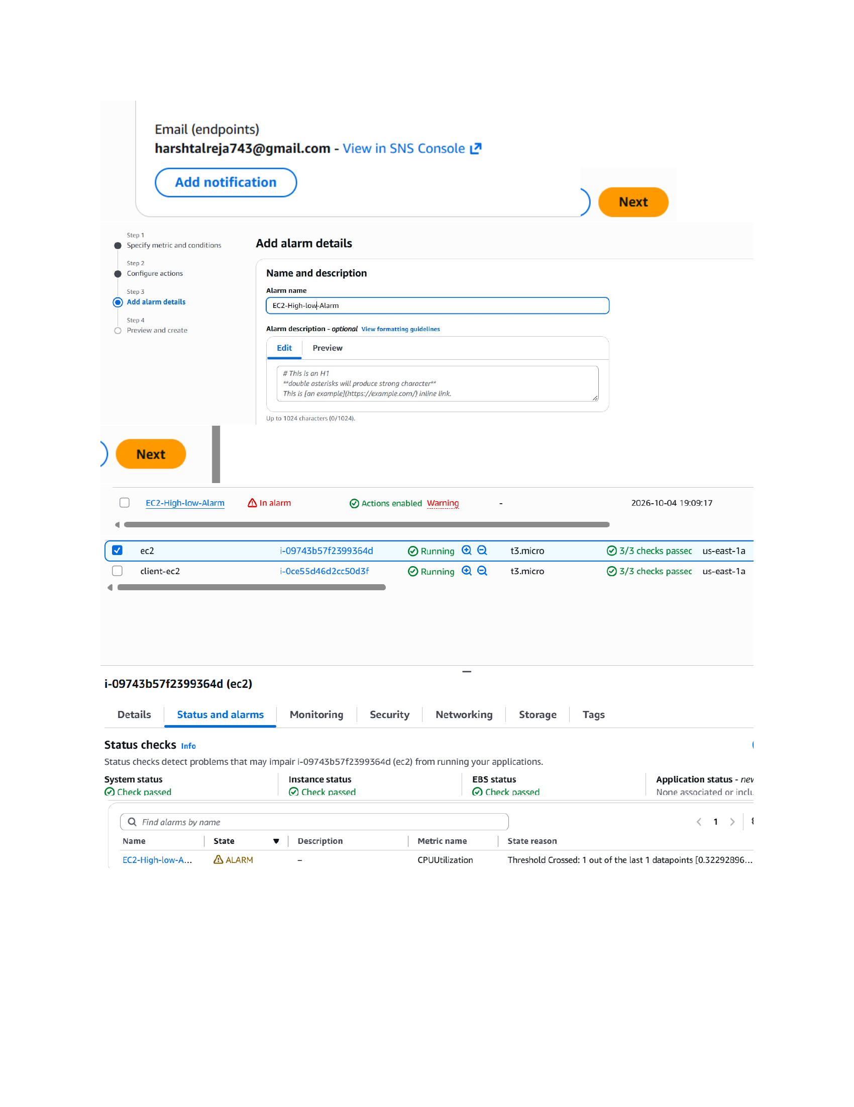
Action: An email notification endpoint is shown, the alarm is named “EC2-High-low-Alarm”, and the alarm is created. The EC2 status-and-alarms view then shows the alarm in ALARM state because the CPUUtilization threshold was crossed.

